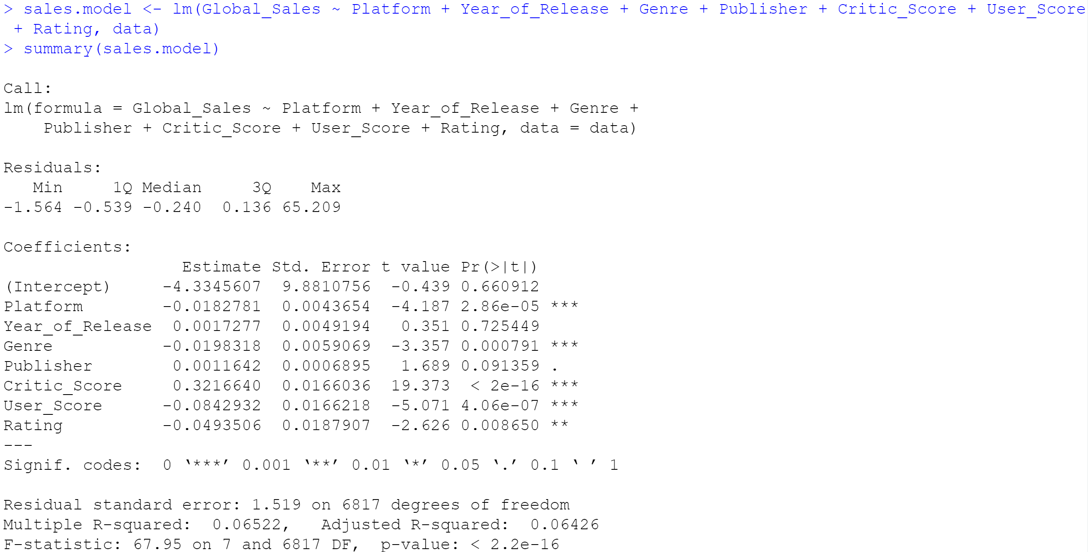

*Platform, Genre, Critic_Score, User_Score* and *Rating* are statistically significant variables when it comes to predicting *Global_Sales*.

The proportion of variance in *Global_Sales* that can be explained by the model’s x variables is 65.22%.

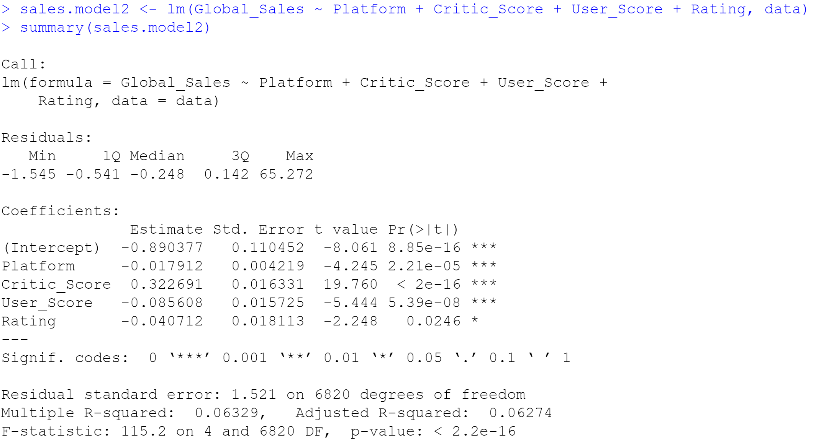

Removing the non-statistically significant variables did not significantly improve the multiple r-squared score. 63.29% of the variance in Global_Sales can be explained by 4 variables with Platform, Critic_Score, and User_Score being the most important. Rating is statistically less significant than the other three variables.